  SPECIALIST MODULE 2  BEHAVIOUR SUPPORT  Early Childhood Supports | The Rosewood Centre commits to meeting and exceeding the following NDIS standards when delivering support to children and their families.  3.7 Outcome-Based Approach: Each participant receives supports that are outcome-based and goal-focused. | - 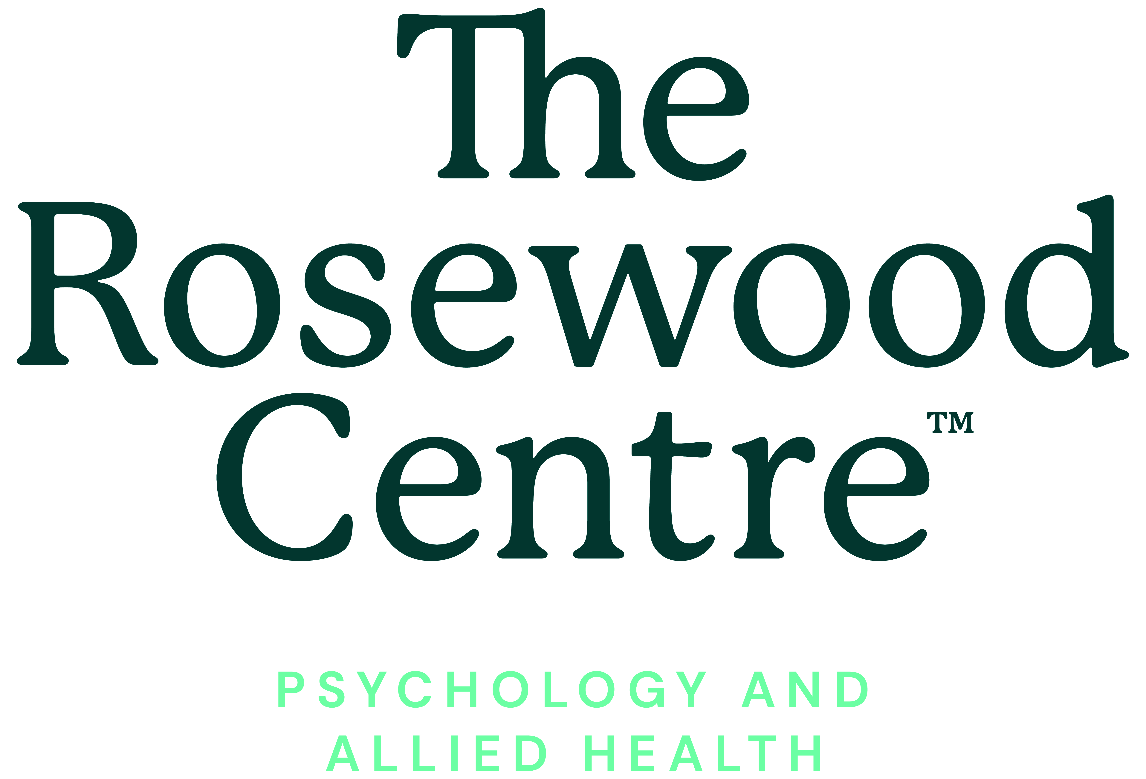  The Rosewood Centre strives to meet and exceed the required NDIS standards in the provision of services.  This brochure contains information about these standards that we hope you might find useful  Should you wish to access additional information or discuss a Referral to the Rosewood Centre for Early Childhood Supports or Behaviour Support, please do not hesitate to contact us on:  Toll free  1800 613 155  Email  hello@rosewoodcentre.com.au
  The Rosewood Centre commits to meeting and exceeding the following NDIS standards when delivering support to people seeking Behaviour Support Services.
  2.1 Each participant accesses behaviour support that is appropriate to their needs which incorporates evidence-informed practice and complies with relevant legislation and policy frameworks.
  2.2 Each participant is only subject to a restrictive practice that meets any state and territory authorisation (however described) requirements and the relevant requirements and safeguards outlined in Commonwealth legislation and policy.
  2.3 Each participant’s quality of life is maintained and improved by tailored, evidence-informed behaviour support plans that are responsive to their needs.
  2.4 Each participant’s behaviour support plan is implemented effectively to meet the participant’s behaviour support needs.
  2.5 Each participant has a current behaviour support plan that reflects their needs, improves their quality of life and supports their progress towards positive change. The plan progresses towards the reduction and elimination of restrictive practices, where these are in place for the participant.
  2.6 Each participant that is subject to an emergency or unauthorised use of a restrictive practice has the use of that practice reported and reviewed.
  2.7 Each participant with an immediate need for a behaviour support plan receives an interim behaviour support plan which minimises the risk to the participant and others.
  SPECIALIST MODULE 3
  EARLY CHILDHOOD SUPPORTS
  3.1 The Child: Each child participant accesses supports that promote and respect their legal and human rights, support their development of functional skills, and enable them to participate meaningfully and be included in everyday activities with their peers.
  3.2 The Family: Each family receives family-centred supports that are culturally inclusive, responsive, and focus on their strengths.
  3.3 Inclusion: Each participant accesses supports that engage their natural environments and enable inclusive and meaningful participation in their family and community life.
  3.4 Collaboration: Each participant receives coordinated supports from a collaborative team comprising their family, the provider and other relevant providers, to facilitate their development and address the family’s needs and priorities.
  3.5 Capacity Building: Each participant receives supports that build the knowledge, skills and abilities of the family and other collaborating providers in order to support the child’s learning and development.
  3.6 Evidence - Informed Practice: Each participant receives evidence-informed supports from providers with quality standards and validated practice.
  3.7 Outcome-Based Approach: Each participant receives supports that are outcome-based and goal-focused.
STANDARD MODULE 1  RIGHTS AND RESPONSIBILITIES  The Rosewood Centre commits to meeting and exceeding the following NDIS standards when delivering support to people seeking services funded by the NDIS.  1.1 Person-Centred Supports: Each participant accesses supports that promote, uphold and respect their legal and human rights and is enabled to exercise informed choice and control. The provision of supports promotes, upholds and respects individual rights to freedom of expression, self-determination and decision-making.  1.2 Individual Values and Beliefs: Each participant accesses supports that respect their culture, diversity, values and beliefs.  1.3 Privacy and Dignity: Each participant accesses supports that respect and protect their dignity and right to privacy.  1.4 Independence and Informed Choice: Each participant is supported by the provider to make informed choices, exercise control and maximise their independence relating to the supports provided.  1.5 Violence, Abuse, Neglect, Exploitation and Discrimination: Each participant accesses supports free from violence, abuse, neglect, exploitation or discrimination. | STANDARD MODULE 2  GOVERNANCE AND OPERATIONAL MANAGEMENT  The Rosewood Centre commits to meeting and exceeding the following NDIS standards when delivering support to people seeking services funded by the NDIS.  2.1 Governance and Operational Management: Each participant’s support is overseen by robust governance and operational management systems relevant (proportionate) to the size, and scale of the provider and the scope and complexity of supports delivered.  2.2 Risk Management: Risks to participants, workers and the provider are identified and managed.  2.3 Quality Management: Each participant benefits from a quality management system relevant and proportionate to the size and scale of the provider, which promotes continuous improvement of support delivery.  2.4 Information Management: Management of each participant’s information ensures that it is identifiable, accurately recorded, current and confidential. Each participant’s information is easily accessible to the participant and appropriately utilised by relevant workers.  2.5 Feedback and Complaints Management: Each participant has knowledge of and access to the provider’s complaints management and resolution system. Complaints and other feedback made by all parties are welcomed, acknowledged, respected and well-managed.  2.6 Incident Management: Each participant is safeguarded by the provider’s incident management system, ensuring that incidents are acknowledged, respond to, well-managed and learned from.  2.7 Human Resource Management: Each participant’s support needs are met by workers who are competent in relation to their role, hold relevant qualifications, and who have relevant expertise and experience to provide person-centred support. | GOVERNANCE AND OPERATIONAL MANAGEMENT cont.  2.8 Continuity of Supports: Each participant has access to timely and appropriate support without interruption.  2.9 Emergency and disaster management includes planning that ensures that the risks to the health, safety and wellbeing of participants that may arise in an emergency or disaster are considered and mitigated, and ensures the continuity of supports critical to the health, safety and wellbeing of participants in an emergency or disaster  STANDARD MODULE 3  PROVISION OF SUPPORTS  3.1 Access to Supports: Each participant accesses the most appropriate supports that meet their needs, goals and preferences.  3.2 Support Planning: Each participant is actively involved in the development of their support plans. Support plans reflect participant needs, requirements, preferences, strengths and goals, and are regularly reviewed.  3.3 Service Agreements with Participants: Each participant has a clear understanding of the supports they have chosen and how they will be provided.  3.4 Responsive Support Provision: Each participant accesses responsive, timely, competent and appropriate supports to meet their needs, desired outcomes and goals.  3.5 Transitions to or from the Provider: Each participant experiences a planned and coordinated transition to or from the provider.

